EXCERCISE 2
DISK SCHEDULING
Post Work

Question

write a program which compare FCFS,SSTF,SCAN,C-SCAN,LOOK,C-LOOK
disk scheduling algorithm for a given input and choose the optimal one.

CODE

#include<stdio.h> \\abhishekmano
#include<stdlib.h>
void swap(int *a,int *b){
int temp;
temp=*a;
*a=*b;
*b=temp;
}
float fcfs(int n,int init,int req[]){
float total=0;
int i;
for(i=0;i<n;++i){
if(req[i]<=init){
total+=init-req[i];
printf("Move from\t%d\tto\t%d\twith seek %d\n",init,req[i],init-req[i]);
}
else{
total+=req[i]-init;
printf("Move from\t%d\tto\t%d\twith seek %d\n",init,req[i],req[i]-init);
}
init=req[i];
}

printf("***Total seek time is %f ***\n",total);
printf("***Average seek time is %f ***\n",total/n);
return total;
}

float sstf(int n,int init,int size,int req[]){
int min,i,maxex=0,minex=0,count=n,least,max;
float total=0;
for(min=0;req[min]<=init && min < n;++min);
//printf("%d",req[min]);
min--;
max=min+1;
while(count > 0 ){
if(max >= n){
maxex=1;
break;
}
if(min < 0){
minex=1;
break;
}
least=init-req[min];
if(least > (req[max]-init)){
total+=req[max]-init;
//printf("inside while max side");
printf("Move from\t%d\tto\t%d\twith seek %d\n",init,req[max],req[max]-init);
init=req[max];
max++;
count--;
}
else{
total+=init-req[min];
//printf("inside while minside");
printf("Move from\t%d\tto\t%d\twith seek %d\n",init,req[min],init-req[min]);
init=req[min];
min--;
count--;
}
}
if(maxex==1)
for(i=min;i>=0;--i){
total+=init-req[i];
printf("Move from\t%d\tto\t%d\twith seek %d\n",init,req[i],init-req[i]);
init=req[i];
}
if(minex==1)
for(i=max;i<n;++i){
total+=req[i]-init;
printf("Move from\t%d\tto\t%d\twith seek %d\n",init,req[i],req[i]-init);
init=req[i];
}
printf("***Total seek time is %f ***\n",total);
printf("***Average seek time is %f ***\n",total/n);
return total;
}

float scan(int n,int init,int size,int req[]){ \\abhishekmano
int min=0,i;
float total=0;
for(min=0;req[min]<=init && min < n;++min);
//printf("%d",req[min]);
min--;
for(i=min;i>=0;--i){
total+=init-req[i];
printf("Move from\t%d\tto\t%d\twith seek %d\n",init,req[i],init-req[i]);
init=req[i];
}
if(min == n-1)
return total;
if(init!=0){
printf("Move from\t%d\tto\t0\twith seek %d\n",init,init);
total+=init;
init=0;
}
if( min+1 < n )
for(i=(min+1);i<n;++i){
total+=req[i]-init;
printf("Move from\t%d\tto\t%d\twith seek %d\n",init,req[i],req[i]-init);
init=req[i];
}

printf("***Total seek time is %f*** \n",total);
printf("***Average seek time is %f*** \n",total/n);
return total;
}

float cscan(int n,int init,int size,int req[]){ \\abhishekmano
int min=0,i;
float total=0;
for(min=0;req[min]<=init && min < n;++min);
//printf("%d",req[min]);
min--;
for(i=min;i>=0;--i){
total+=init-req[i];
printf("Move from\t%d\tto\t%d\twith seek %d\n",init,req[i],init-req[i]);
init=req[i];
}
if(min == n-1)
return total;
if(init!=0){
printf("Move from\t%d\tto\t0\twith seek %d\n",init,init);
total+=init;
init=0;
}
printf("Move from\t0\tto\t%d\twith seek %d\n",size-1,size-1);
init=size-1;
total+=size-1;
for(i=n-1;i>min;--i){
total+=init-req[i];
printf("Move from\t%d\tto\t%d\twith seek %d\n",init,req[i],init-req[i]);
init=req[i];
}

printf("***Total seek time is %f*** \n",total);
printf("***Average seek time is %f*** \n",total/n);
return total;
}
float look(int n,int init,int size,int req[]){ \\abhishekmano
int min=0,i;
float total=0;
for(min=0;req[min]<=init && min < n;++min);
//printf("%d",req[min]);
min--;
for(i=min;i>=0;--i){
total+=init-req[i];
printf("Move from\t%d\tto\t%d\twith seek %d\n",init,req[i],init-req[i]);
init=req[i];
}
for(i=(min+1);i<n;++i){
total+=req[i]-init;
printf("Move from\t%d\tto\t%d\twith seek %d\n",init,req[i],req[i]-init);
init=req[i];
}

printf("***Total seek time is %f*** \n",total);
printf("***Average seek time is %f*** \n",total/n);
return total;
}
float clook(int n,int init,int size,int req[]){
int min=0,i;
float total=0;
for(min=0;req[min]<=init && min < n;++min);
//printf("%d",req[min]);
min--;
for(i=min;i>=0;--i){
total+=init-req[i];
printf("Move from\t%d\tto\t%d\twith seek %d\n",init,req[i],init-req[i]);
init=req[i];
}
if(min == n-1)
return total;
total+=req[n-1]-init;
printf("Move from\t%d\tto\t%d\twith seek %d\n",init,req[n-1],req[n-1]-init);
init=req[n-1];
for(i=n-2;i>min;--i){
total+=init-req[i];
printf("Move from\t%d\tto\t%d\twith seek %d\n",init,req[i],init-req[i]);
init=req[i];
}

printf("***Total seek time is %f*** \n",total);
printf("***Average seek time is %f*** \n",total/n);
return total;
}

int main(){ \\abhishekmano
int size,init,n,pos,i,j;
float total=0;

printf("Enter the Disk size: ");
scanf("%d",&size);
printf("Enter the initial head position: ");
scanf("%d",&init);
pos=init;
printf("Enter the number of requests: ");
scanf("%d",&n);

int *req=(int *)malloc(n*sizeof(int));
printf("Enter the request\n");
for(i=0;i<n;++i){
scanf("%d",&req[i]);
if(req[i]>=size || req[i]<0){
printf("are you dumb\n");
return 0;
break;
}
}
printf("~~~~~~~~~~~~~~~~~~~~~~~~~~~FCFS~~~~~~~~~~~~~~~~~~~~~~~~~~\n");
float tfcfs = fcfs(n,init,req); /////////////
for(i=0;i<n-1;++i)
for(int j=i;j<n;++j)
if(req[i]>req[j])
swap(&req[i],&req[j]);
printf("~~~~~~~~~~~~~~~~~~~~~~~~~~~SSTF~~~~~~~~~~~~~~~~~~~~~~~~~~~\n");
float tsstf = sstf(n,init,size,req); //////////////

printf("~~~~~~~~~~~~~~~~~~~~~~~~~~~SCAN~~~~~~~~~~~~~~~~~~~~~~~~~~~\n");
float tscan = scan(n,init,size,req); //////////////

printf("~~~~~~~~~~~~~~~~~~~~~~~~~~~C-SCAN~~~~~~~~~~~~~~~~~~~~~~~~~\n");
float tcscan= cscan(n,init,size,req); //////////////

printf("~~~~~~~~~~~~~~~~~~~~~~~~~~~LOOK~~~~~~~~~~~~~~~~~~~~~~~~~~~\n");
float tlook = look(n,init,size,req); //////////////

printf("~~~~~~~~~~~~~~~~~~~~~~~~~~~C-LOOK~~~~~~~~~~~~~~~~~~~~~~~~~\n");
float tclook = clook(n,init,size,req); //////////////
int arr[6];
arr[0]=(int)tfcfs;
arr[1]=(int)tscan;
arr[2]=(int)tcscan;
arr[3]=(int)tlook;
arr[4]=(int)tclook;
arr[5]=(int)tsstf;
for(i=0;i<5;++i)
for(j=i+1;j<6;++j)
if(arr[i]>arr[j])
swap(&arr[i],&arr[j]);
if(arr[0]==tfcfs)
printf("FCFS is the optimal With total seek time %f Average seek time %f\n",tfcfs,tfcfs/n);
else if(arr[0]==tscan)
printf("SCAN is the optimal With seek time %f Average seek time %f\n",tscan,tscan/n);
else if(arr[0]==tcscan)
printf("C-SCAN is the optimal With seek time %f Average seek time %f\n",tcscan,tcscan/n);
else if(arr[0]==tlook)
printf("LOOK is the optimal With seek time %f Average seek time %f\n",tlook,tlook/n);
else if(arr[0]==tclook)
printf("C-LOOK is the optimal With seek time %f Average seek time %f\n",tclook,tclook/n);
else if(arr[0]==tsstf)
printf("SSTF is the optimal With seek time %f Average seek time %f\n",tsstf,tsstf/n);

return 0;
}

Output

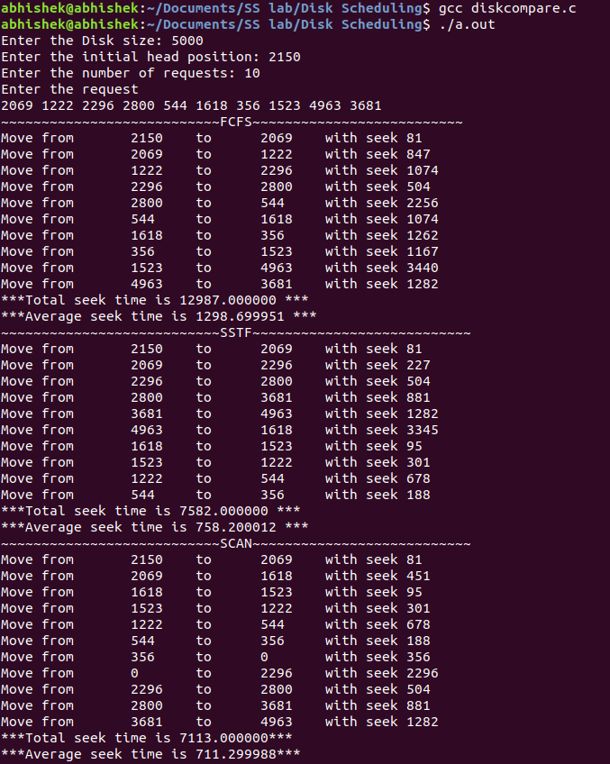

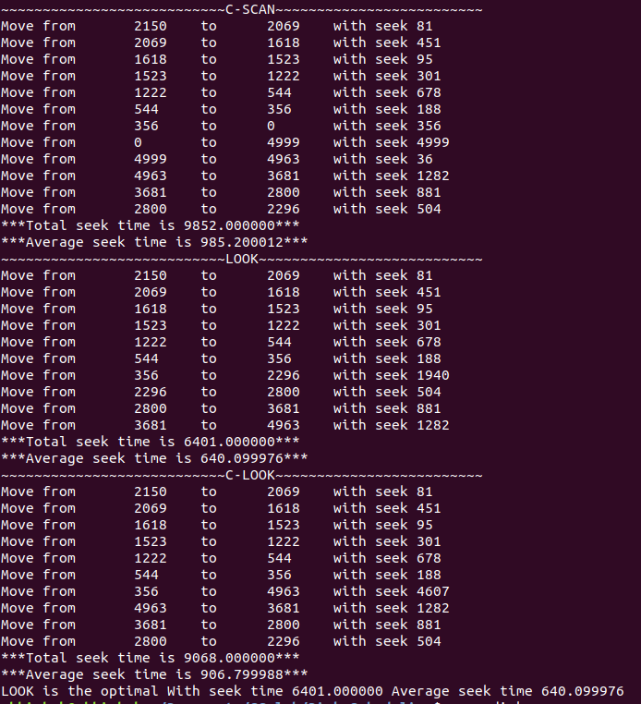

Abhishek Manoharan
Roll no 2

